**Date: 05.04.17**

**SUPROTIK DEY**

**IT Hx-31**

**4TH SEM, 510815050**

**9. Write a program in Matlab to simulate the growth of a scale-free network and a random network and realize its degree distribution of nodes.**

**SOURCE CODE:**

clear;

clc;

%random network

iterations = 100

Net = [0 1 0 1; 1 0 1 0; 0 1 0 1; 1 0 1 0]

for i=1:iterations

[~,numofnodes] = size(Net);

% 0 => edge, 1 => node

b=round(rand(1,numofnodes));

Net=[[Net;b] [b 0]'];

end;

Net

hist(sum(Net));

hold on;

clc;

%scalefree network

Net = [0 1 0 1;

1 0 1 0;

0 1 0 1;

1 0 1 0]

for i=1:iterations

%decide if edge or node is to be added, 0 mean edge is added

[~,numofnodes] = size(Net);

edgeOrNode = round(rand(1));

if(edgeOrNode==0)

%check if network has max edges

edgeSum=sum(sum(Net));

if(edgeSum >= ((numofnodes*numofnodes) - numofnodes))

continue;

end;

%edge is added

while(1)

n1=round(random('unif',1,numofnodes));

n2=round(random('unif',1,numofnodes));

if((n1~=n2))

break;

end;

end;

Net(n1,n2)=1;

Net(n2,n1)=1;

else

%node is added

b=zeros(1,numofnodes);

Net=[[Net;b] [b 0]'];

NumofEdges=round(random('unif',1,numofnodes));

if(NumofEdges==0)

NumofEdges=1;%nodes cannot come without one edge

end;

for k=1:NumofEdges

%find out fulldegree sum

fullDegreeSum=sum(sum(Net));

%add edge acc to degree sum

edgeAddSum = round(random('unif',1,fullDegreeSum));

fullDegreeSum = 0;

degSumArr=sum(Net);

for j=1:numofnodes

fullDegreeSum = fullDegreeSum + degSumArr(j);

if(edgeAddSum>=fullDegreeSum)

break;

end;

end;

Net(j,numofnodes+1)=1;

Net(numofnodes+1,j)=1;

end;

end;

end;

Net

[~,numofnodes] = size(Net);

numofnodes

hist(sum(Net));

h = findobj(gca,'Type','patch');

set(h(1),'FaceColor','y','EdgeColor','k');

**OUTPUT:**

Net =

0 1 0 1

1 0 1 0

0 1 0 1

1 0 1 0

numofnodes =

55

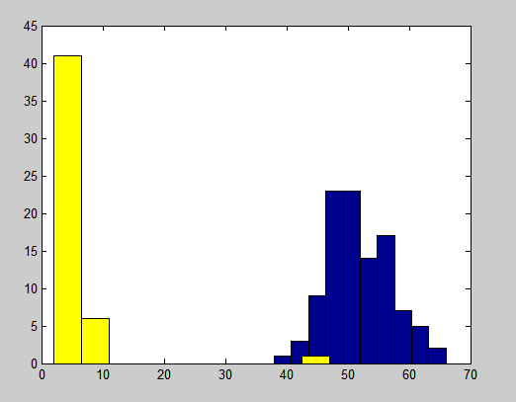

Legend:

Random

Scale free